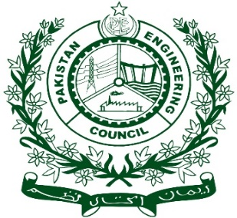

Pakistan Engineering Council
Summary Form for PEC Visit Report Manual 2014

< Engineering Program >

<Name of HEI>
<Type of Visit>
(Date of Visit)

 | University/Institution
 | Name of Program
 | Name of Degree Awarding University
 | Visit Date
 | PEC Team Composition  (with organization/HEIs) | Convener/Team Leader |  |  | PEV/Expert < Engineering >
 |  | PEV/Expert < Engineering > |  |  | Industry Representative
 |  | Name of PEC Representative
 | Accreditation History | Year of Accreditation Intake Batch/year Accreditation Granted for number of years Ref of EA&QEC  Last Accr
 | Students Strength  (yearly/batch-wise) | Year/Batch (Spring or Fall) Allowed Intake (students per year) Present Strength No of Sections  - - - -  - - - -  - - - -  - - - -  Grand Total - -
 | * Faculty Summary (Core Engineering)
 |  | Ph.D. | M.S / M.E | B.S / B.E  (Enrolled in Master) |  | Countable Faculty
 | Dedicated | - | - | - |  | -
 | Shared | - | - | - |  | -
 | Grand Total | - | - | - |  | -
 | Students-Teacher Ratio | -
 | CQI- Compliance/Progress
 | Observations as per laid down PEC criteria:
 | - Deficiencies
b. Weak Areas
Criterion-<>:
Sub-criterion (-):
Sub-criterion (-):

Criterion-<>:
Sub-criterion (-):
Criterion-<>:
Sub-criterion (-):
c. Concerns
Criterion-<>:
Sub-criterion (-):
Sub-criterion (-):
Criterion-<>:
Sub-criterion (-):
Criterion-<>:
Sub-criterion (-):
Violations (if any):
Sr. No. | Intake Year  (Last 04 years) | Allowed Intake | Students Applied | Students Admitted | High Intake (% age) | No of D.A.E admitted students | No of students less than 60% marks in HSSC (Pre-Engg.)

Any other Violation:
 | Rejoinder received and attached as Annex-I
 | Recommendations of PEC Visiting Team:
 | Recommendations by the Moderation Review Committee (MRC):

